Waiver of Fees for Church Members

If either the bride or the groom is a member of Grace UMC, the pastor’s honorarium is waived. (This is based on the assumption that the couple is already supporting the church through their regular giving.) Because the organist is a part-time employee, we ask that members as well as non-members pay the honorarium.

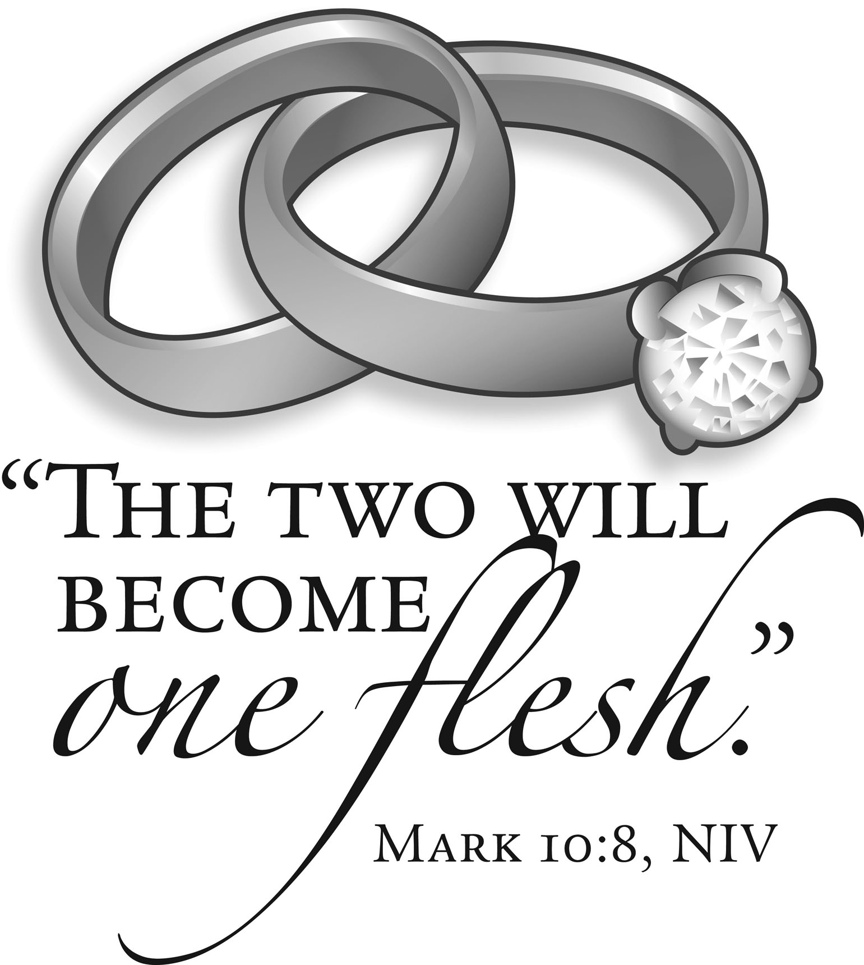

Guidelines for
Weddings

Grace United Methodist Church
121 Pleasant Street, Southington, CT 06489
860- 628-6996
graceumc_office@cox.net
www.graceumcsouthington.org

A Service of Christian Marriage

A Service of Christian Marriage is provided for couples who wish to solemnize their marriage in a service of Christian worship. Christian marriage is proclaimed as a sacred covenant. It reflects the covenant of our baptism in which we have accepted the power of God in our lives through faith in Jesus Christ, and in which we have promised to remain faithful members of the church and to serve as Christ’s representatives in the world.

Accordingly, the wedding service is structured in the same way as the Sunday worship service, including prayer and the the proclamation of the Scriptures.

The Pastor’s Role in Marriage Preparation

The decision to hold a wedding ceremony in a local united Methodist Church is the responsibility of the pastor of that church. Under our denomination’s Book of Discipline, the pastor is also responsible for counseling with the couple concerning their marriage, and for discussing and planning the service with them. The pastor’s responsibilities include, but are not limited to, the following:

- Order of Service The pastor will consult with you about the format of the service, interpreting the meaning of the wedding liturgy and discussing the options that are available to you within the structure of the service. The intent is to help you prepare a service which expresses what your marriage means
- to you while remaining consistent with the traditions and practices of the United Methodist Church.
- The pastor’s commitment to holding your wedding at Grace is made only when you have had a chance to meet. After that, the pastor will meet with you for premarital counseling sessions before the wedding. Ordinarily, this involves three to five meetings of approximately one hour each.

Honoraria and Fees

In consideration of the services provided by the church staff for your wedding, it is appropriate to provide monetary compensation in the following amounts:

- Organist: $200 The organist is present at the rehearsal and the wedding, and also spends time in selection and preparation of the service music. She will also consult with you, if you desire, on the selection of music. Please make your check payable to Joy Kumme.
- Pastor: $300 The pastor consults with you before the wedding, provides premarital counseling and conducts the rehearsal and wedding service. If you would like the pastor to be present at your reception (schedule permitting) it will be necessary to send an invitation. Please make your check payable to Rev. Carol Downs.

- Grace UMC does not provide any form of food service or preparation. If a reception is planned after the service, families are responsible for making their own arrangements for catering, setup, serving and cleanup. Saints Restaurant of Southington has been a popular choice with families desiring this service.
- Use of the church hall must be requested beforehand, and approved by the pastor and/or a representative of the church Trustees. It is your responsibility to set up tables and chairs, and to store them away.

The Legal End Of The Wedding

You must, of course, have a marriage license! There is no waiting period. The license must be obtained by you from the Connecticut town where you live or from the town where the service will be held. (If the wedding is here at Grace, Southington must be specified on the license.) It is good for 65 days from the date of issue. The license is to be given to the pastor at or before the wedding rehearsal. It is illegal to perform a wedding if the license is not present.

First Steps
- When you contact the church, we will ask for your name, address and telephone number, as well as the date of your intended wedding. (Six months prior to your expected wedding date is an appropriate time to call.) If the date is clear, the pastor will schedule a first meeting with you both.
- If you are planning a wedding at the church, the next step is for you to attend our Sunday service at 10:00
- a.m. If you are not a member, this will give you a chance to get the “feel” of the church, hear a sample of our music, and meet some of the people of our congregation.
- Participation of Other Clergy You may request that clergy from outside this congregation have a part in your wedding. However, it is well-established practice in our denomination that they do so only at the invitation of the current pastor, who will make a decision as to their role in the service.
- Participation of Children Children of the bride or groom, as well as other family members and friends, may take a variety of roles in the service, according to their ages and abilities. This should be discussed with the pastor during the process of consultation concerning your wedding.
- Policies and Guidelines Policies and guidelines established by our congregation (outlined below) will be part of your discussion with the pastor.

Photography and Videotaping

Your wedding will take place before the altar of the church, in the presence of Christ and a gathered congregation. We ask you to understand that reverence and dignity take precedence over photography and videotaping. With this understanding, our church has set the following guidelines:
- Photographs may be taken anytime during the Processional and Recessional. Once the bride and groom are standing with the pastor before the altar, we ask that no further photographs are taken by family or friends.
- One designated photographer, usually a professional, may take non-flash photos during the ceremony from a location designated by the pastor. He or she may also videotape the ceremony from a location agreed upon by the pastor beforehand. After the wedding has concluded, the wedding party is welcome to assemble at the front of the sanctuary for as many photos as you wish. Please make your photographer aware of these requirements.

Music

At your request, the pastor will arrange for the services of our regular organist, or an approved substitute if our organist is unavailable on the date you choose. Only music suitable for a service of worship at Grace UMC may be played during the service, regardless of location. Because the marriage ceremony is a service of worship, the singing of hymns is appropriate. Selection of music must be approved by pastor.

Bulletins

Most couples wish to have a bulletin for their wedding service. This will follow the traditional service format and will be prepared by our office under the direction of the pastor.

Flowers and Decorations

- Flowers If flowers are to be placed on or near the altar we ask you to keep the size of the arrangement within tasteful limits. We ask that you remove all floral arrangements after the end of the service.
- Pew bows We ask that you do not tape bows or other decorations to the pews. Instead, please use clips or hooks as fasteners.
- Unity Candle Please inform the pastor at least two weeks in advance if you wish to use a unity candle. This must be purchased by you, at your expense, and include a tabletop stand. Please buy dripless candles, to avoid damage to our altar and flooring. Also, we request that you provide a mat to be used underneath the stand to prevent dripping.
- Runners You may use your own runners as long as the placement and removal is managed by the family or friends of the wedding party. Please inform the pastor at least two weeks in advance if runners will be used.

Other Considerations

- Christian marriage is a holy moment in which we believe that God is present, and will continue to be present, in the lives of two people who are making a solemn commitment to each other. Therefore, the Pastor reserves the right to refuse to begin the service if he or she believes that any member of the wedding party is under the influence of alcohol or drugs.
- Due to environmental considerations, rice, balloons and confetti are not permitted on the church grounds. The use of bird seed or bubbles is allowed.

